**What is an Operating System?**

**TOTAL POINTS 7**

1.Question 1

What are the two main parts that make up an operating system?

**1 / 1 point**



Windows and Mac



Kernel and Userspace



Kernel and Packages



Users and Software

Ans 2

**Correct**

Wohoo! The two parts that make up an operating system are the kernel and the user space.

2.Question 2

What are the main components of file management? Check all that apply.

**1 / 1 point**



NTFS



Metadata

**Correct**

You got it! The main components of file management are the storage of data, the file metadata, and the filesystem.



File data

**Correct**

You got it! The main components of file management are the storage of data, the file metadata, and the filesystem.



File system

**Correct**

You got it! The main components of file management are the storage of data, the file metadata, and the filesystem.

3.Question 3

Which of these are true? Check all that apply.

**1 / 1 point**



A program is a process that is executed. A process is a program that we can run.



A program is initially stored in RAM. A process is initially stored in the hard drive.



A program is an application that we can run. A process is a program that is executed.

**Correct**

Great job! A program is an application, and a process is an application that is executed. You can have many processes running for the same program.



You can have many processes running for one program.

**Correct**

Great job! A program is an application, and a process is an application that is executed. You can have many processes running for the same program.

4.Question 4

What are the characteristics of virtual memory? Check all that apply.

**1 / 1 point**



Combination of RAM and hard drive space.

**Correct**

Excellent job! Virtual memory allows us to extend the physical memory on our machine.



It is where we store pages that are being executed



Stores pages that are currently not in use by physical memory.

**Correct**

Excellent job! Virtual memory allows us to extend the physical memory on our machine.



Allows our computer to have more memory than it physically has.

**Correct**

Excellent job! Virtual memory allows us to extend the physical memory on our machine.

5.Question 5

Which of these is a GUI? Check all that apply.

**1 / 1 point**



Option One

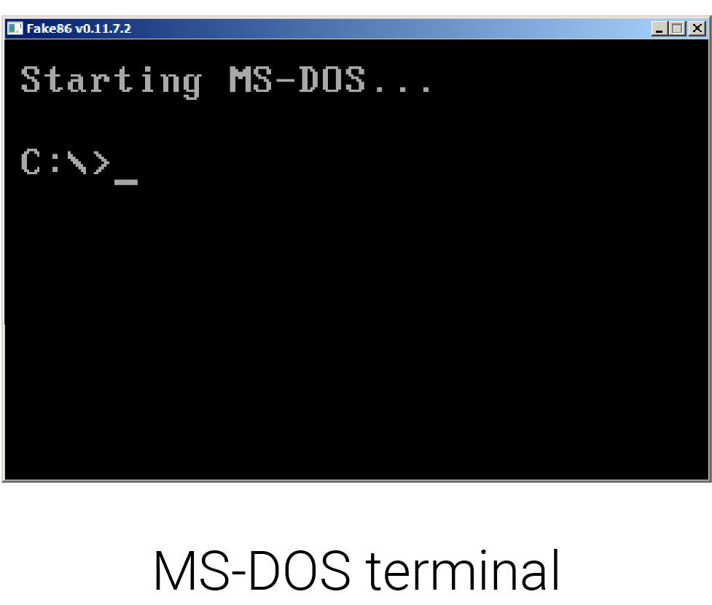



Option Two

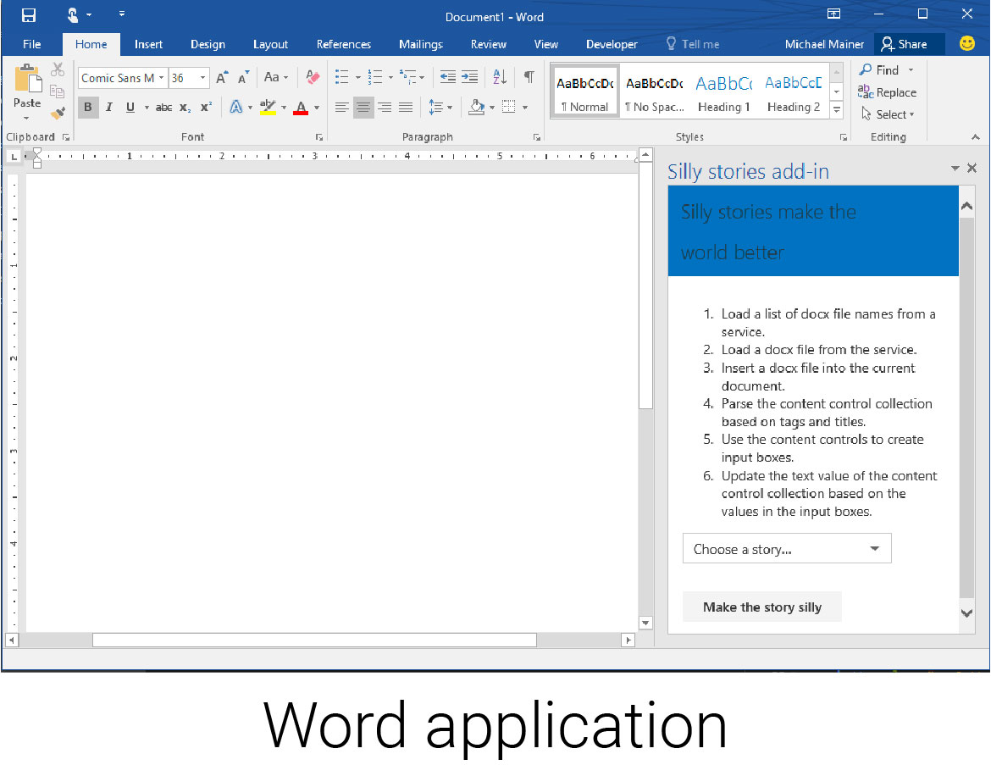

**Correct**

Great job! These are all examples of a GUI.



Option Three

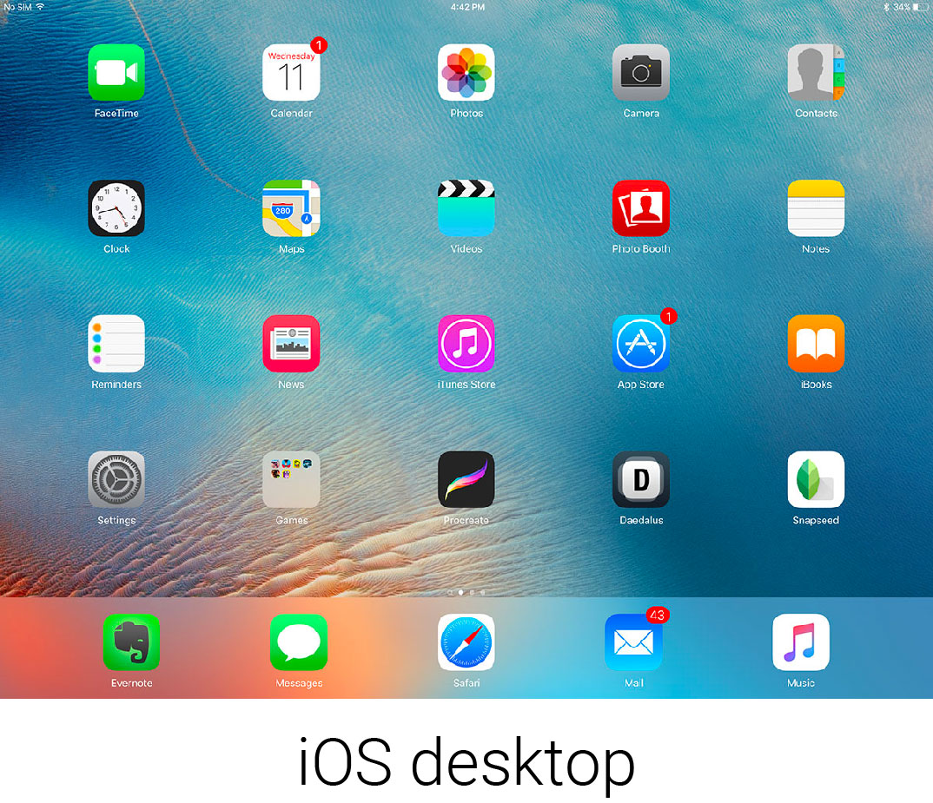

**Correct**

Great job! These are all examples of a GUI.



Option Four

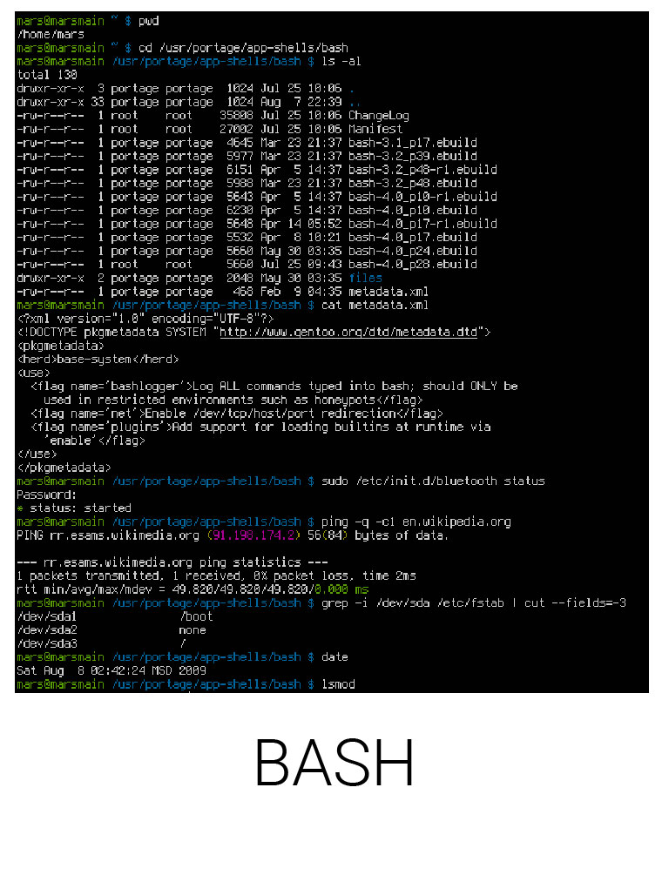

6.Question 6

Which of these are considered I/O devices? Check all that apply.

**1 / 1 point**



Hard disk drives

**Correct**

Excellent job! Any devices that receive input or send out output are considered I/O devices.



Monitors

**Correct**

Excellent job! Any devices that receive input or send out output are considered I/O devices.



Speakers

**Correct**

Excellent job! Any devices that receive input or send out output are considered I/O devices.



Web cams

**Correct**

Excellent job! Any devices that receive input or send out output are considered I/O devices.

7.Question 7

What is the last step in booting a computer?

**1 / 1 point**



Perform a POST.



User space is launched.



Load up drivers.



Execute the bootloader.

Ans 2

**Correct**

Well done, you! The last step in booting a computer is launching the user space, like a login window, GUI, and more.